EXPERIMENT-07 DHILIPAN M
21/07/2026 192411038

BEST FIRST SEARCH (BFS) ALGORITHM
AIM:
To write a Python program to implement the Best First Search (BestFS) algorithm for finding the shortest path between two nodes in a graph.
ALGORITHM:
Step 1: Represent the graph using an adjacency list with heuristic values.
Step 2: Initialize the priority queue with the start node.
Step 3: Mark the visited nodes to avoid revisiting them.
Step 4: Select the node with the lowest heuristic value from the priority queue.
Step 5: Expand its neighboring nodes and add unvisited neighbors to the priority queue.
Step 6: Continue until the goal node is reached or no path exists.
PROGRAM:
from queue import PriorityQueue
graph = {
'A': [('B', 6), ('C', 3)],
'B': [('D', 2), ('E', 4)],
'C': [('F', 5), ('G', 1)],
'D': [],
'E': [],
'F': [],
'G': []
}

heuristic = {
'A': 7,
'B': 6,
'C': 2,
'D': 1,
'E': 4,
'F': 3,
'G': 0
}
start = 'A'
goal = 'G'
pq = PriorityQueue()
pq.put((heuristic[start], start, [start]))
visited = set()

while not pq.empty():
h, node, path = pq.get()

if node == goal:
print("Goal Found")
print("Path:", " -> ".join(path))
break

if node in visited:
continue

visited.add(node)

for neighbor, cost in graph[node]:
if neighbor not in visited:
pq.put((heuristic[neighbor], neighbor, path + [neighbor]))
else:
print("Goal Not Found")

OUTPUT:

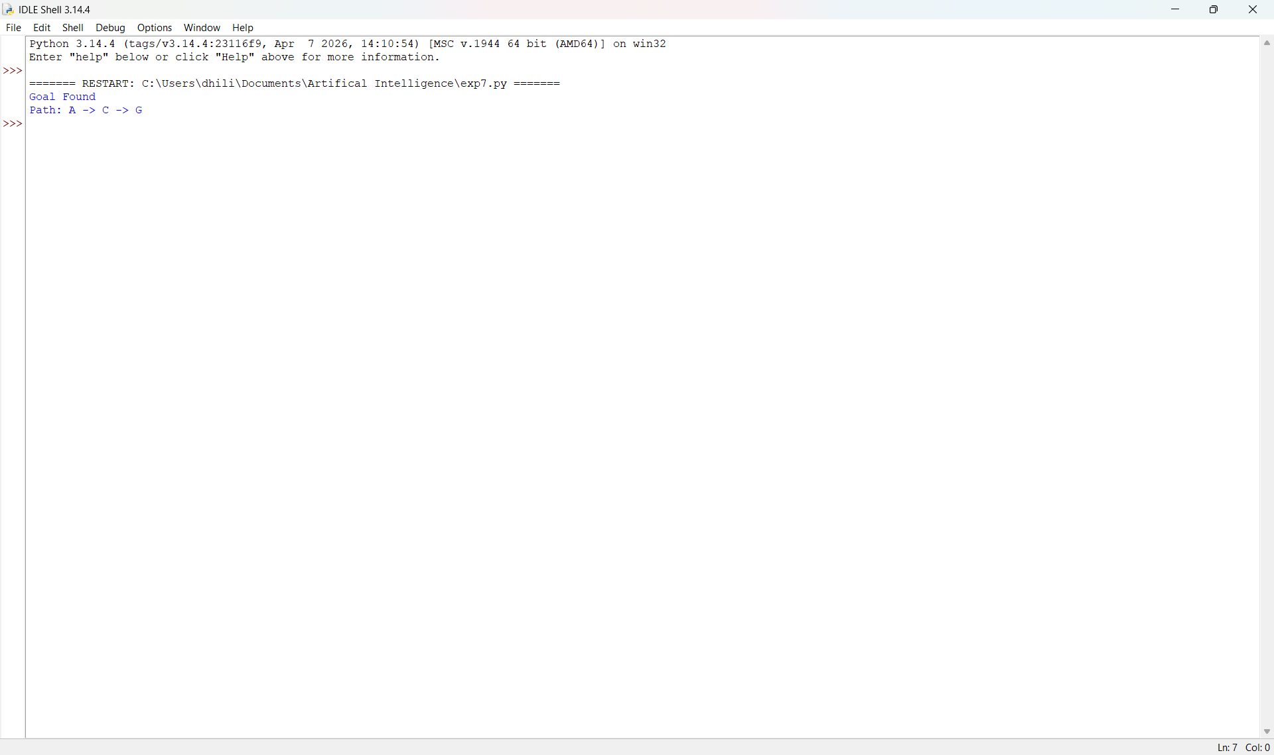

RESULT:
Thus, the Python program to implement the Best First Search (BestFS) algorithm was implemented successfully and the required output was obtained.

